**The Grill House- Restaurant Management System**

**PC BA - Business Analyst Capstone**

Course-end Project 1

**Submitted By**- Ashwini Suresh Lanjewar

**Table of Content**

1. Introduction

1.1Business Analysis Core Concept Model (BACCM)

1. Identify Stakeholders
2. Identify the Problem Statement
3. Create As-is and Future process map
4. Scope of Restaurant Management system(Context Diagram)
5. Main features of Restaurant Management System
6. In-Scope and Out-of-Scope items
7. Business Requirements (Functional and Non-functional Requirements)
8. Draw Wireframes for any two features
9. Excel
10. Tableau Dashboards
    * 1. **Introduction**

A US celebrity chef James Oliver has his own chain of restaurants, The Grill House, across different cities in the USA. He wanted to put a new Restaurant Management System to track the day-to-day management of his restaurant.

Currently they have a paper-based system for the same and this has many issues. Currently the orders were taken by the waiters on paper and a paper-based bill was presented to the customers.

All the bills were entered into an excel sheet by the manager at EOD to know the total sales and item wise sales for the day. Then reports were generated on excel to know trends and details like daily, weekly, and monthly sales. Which dishes were popular and which weren’t doing so well?

Restaurants need a system that will allow them to easily update their menu. The clients currently do not have a system that recognizes the different types of users such as managers, waiters, etc. and they would like to be able to limit the access of some options of the system to certain users.

1.1 **BUSINESS ANALYSIS CORE CONCEPT MODEL (BACCM)**

Business Analysis Core Concept Model is a conceptual framework for business analysis. BACCM has 6 core concepts namely: Need, Change, Solution, Context, Value & Stakeholders.

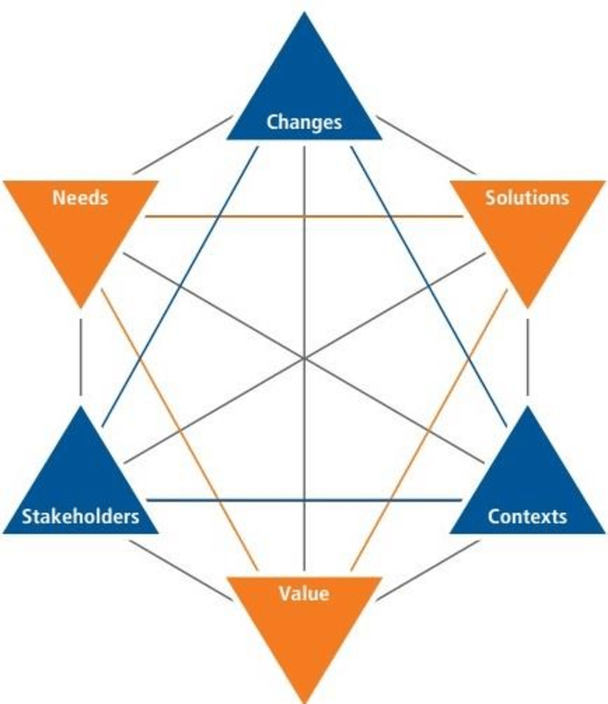

* 1. **IDENTIFY STAKEHOLDERS**

* 1. **IDENTIFY THE PROBLEM STATEMENT**

Currently they have a paper-based system for tracking day to day activities and this has many issues. Currently the orders were taken by the waiters on paper and a paper-based bill was presented to the customers.

All the bills were entered into an excel sheet by the manager at EOD to know the total sales and item wise sales for the day. Then reports were generated on excel to know trends and details like daily, weekly, and monthly sales. Which dishes were popular and which weren’t doing so well?

They are not able to easily update their menu. The clients currently do not have a system that recognizes the different types of users such as managers, waiters, etc.

* 1. **AS-IS AND FUTURE PROCESS MAP**

**AS-IS**

**FUTURE PROCESS MAP**

* 1. **SCOPE OF THE RESTAURANT MANAGEMENT SYSTEM:**

|  |  |  |
| --- | --- | --- |
| User Roles | Component Features | Authorization |
| Waiters | Menu Lists | View |
| Feedback Form | View |
| Order Meal | View, Edit |
| Order Status | View |
| Table Reservations | View |
| Restaurant Manager | Menu List | View, Add, Edit |
| Feedback Form | View, Add |
| Order Meal | View |
| Order Status | View, Edit |
| Order Status | View |
| Group Orders by Menu Items | View |
| Request Delivery | Edit |
| Order Prep Team | Table Reservations | View, Edit |
| Table Reservations | View |
| Order Status | View |
| CEO | Reports | View |

**The scope of the restaurant management system is displayed below in the form of context diagram:**

* 1. **Main features of RMS**

1. System should be able to create a menu. The menu should be categorized into following sections:

* Starters
* Soups
* Main Course
* Desserts
* Drinks

Every item in the menu stored should be categorized into any one of the above heads. Each item should be saved in the system along with its price. For example, Green Thai Curry - price $12, Pasta – $10 and so on. This menu should be created and edited by the managers only. They should be able to add new items, delete existing items, as well as create new menus from scratch.

1. Waiters and managers should be able to search items in the menu using the search facility.
2. Every waiter and manager should have access to the software. Waiters shall use this system for generating the bill table wise. Every bill shall be tagged to the waiter generating it and the table number. Waiters cannot edit the menu. Waiters shall use the system only to generate bills.
3. The system should be able to reserve tables. This reservation would be done by managers only. The waiters shall not seat anyone on the tables reserved. The waiters shall look into the software to determine which tables need to be reserved. The table layout is to be stored in the system.
4. Management wants certain reports at the end of the day. Please give the report formats for the following reports:

* Total sales of the day by dine in customers
* Total sales of the day by home delivery customers
* Total sales of the day (home delivery and dine in customers consolidated)
* Name the top 10 most sold dishes for the day
* Total sales every weekend (to be done by inputting the dates)
* Total sales every month (to be done by inputting the dates)
* List of dishes not sold in the current month (this is to phase out dishes that customers are not ordering)
* Total sales across all cities
* Total sales for each city

1. Login for waiters, managers, and James Oliver (CEO). Change password facility to be offered.
2. Customers can pay by cash or card. There should be a payment gateway on the system.
3. System should be able to generate the bill.
4. James Oliver would like a feedback form (paper) to be given to every customer. This form shall capture details like name, address, mobile number, email, date of birth, anniversary dates of the customers, and their feedback. These details shall be added by the manager manually into the system.
   1. **IN-SCOPE AND OUT-SCOPE ITEMS FOR THIS SOFTWAFRE**

In- Scope:

* Mangers, Employees, Waiters and Customers can view the menu
* Waiters and Customers can order meal
* Waiters and chefs can view orders
* Customers and Waiters can edit orders
* Order delivery to the customer
* Payment Gateway for the customers
* Create and Update menu for Managers
* Table reservations can be done online by customers
* Table allocation by managers
* Generation of bills by waiters for each table
* Customer feedback to be entered by manager
* Reports and data created for the CEO by the system

Out-of Scope:

* Prepaid Payments
* Vendors details or inventory management
* Tracking orders delivery
  1. **Functional and Non-Functional Business Requirements**
     + 1. **Functional Requirements**
* Employees details should be stored in the system. Employees login credentials will be stored in the systems.
* The waiters should be able to see the reserved tables, seat the customers based on the available tables, view the menu, take the orders and generate bills.
* Waiters and managers can search the dish on menu
* Managers should be able to reserve tables, & change password facility
* Managers can create, update and edit menu
* Manager should be able to view the orders placed by the waiter
* Chefs should be able to view the order and prepare the order
* Waiters should be able to generate table wise bills
* Bill payments to be done by customer through the payment gateways
* Managers and waiter to give feedback form to the customers
* Generate Reports as required by the management
* Total sales of the day by dine in customers
* Total sales of the day by home delivery customers
* Total sales of the day (home delivery and dine in customers consolidated)
* Name the top 10 most sold dishes for the day
* Total sales every weekend (to be done by inputting the dates)
* Total sales every month (to be done by inputting the dates)
* List of dishes not sold in the current month (this is to phase out dishes that customers are not ordering)
* Total sales across all cities
* Total sales for each city

1. **Non- Functional Requirements**

* Usability- The system should be user friendly and easily accessible
* Scalability and Performance- The system should support all the employees across all the states in USA. The web page should be fast and the information should be accessed quickly
* Availability- The system should be efficient and should be available always for the customers and employees
* Security- The users should be verified and secure credentials or passwords should be created by the employees and customers
* Compliance- HR compliance and policy
  1. **Mock Screen/ Wireframe of COS**

**Excel**

Question 1:

1. Create a bar graph for San Jose, Madison, and New York showing the sales. Label the chart drawn correctly so that senior management gets a clear report of sales.
2. Arrange the data above in excel in an ascending and descending order for each city.

Question 2:

1. In the above chart for restaurant ID 1200789, find the sales for the month of June
2. In the above chart for restaurant ID 1200739, find the sales for the month of April
3. In the above chart for restaurant ID 1200352, find the sales for the month of January

**Project Task: Week 3 (This is on the Tableau concepts taught)**

1. Create a dashboard for senior management to view sales of restaurants for the last six months. Make assumptions as appropriate and create the dashboard using your own mock data.
2. Create a dashboard to show which zone (Zone 1, 2, 3, or 4) has highest sales. Make assumptions as appropriate and create the dashboard using your own mock data.

1. Create a dashboard for senior management to view sales of restaurants for the last six months. Make assumptions as appropriate and create the dashboard using your own mock data.

1. Create a dashboard to show which zone (Zone 1, 2, 3, or 4) has highest sales. Make assumptions as appropriate and create the dashboard using your own mock data.

